# Google Engine Search by SerpAPI

# Python – Create the Google search JSON.

Project contact: GCP Guild moderator, Kyndryl

Email: Ramamurthy.valavandan@kyndryl.com

Python API for Google Search Engine

Use Case: Creating the Temples List, Description of Temple, Co-ordinates, Distances from major cities in India.

"""

Purpose: After connecting to Google Search Engine API the JSON is generated

This program is used to connect Google Search API (SerpAPI)

Download the searched information which is saved in the JSON file based on the Google Search Engine.

Create the necessary folders in local and download and save JSON for locally parse the search key.

---------------------------------------------------------------------------------------------------

SerpAPI Sponsorship

Google Engine is sponsored by SerpApi. SerApi has sponsored 40,000 credits for Google search

with the API Key for scraping Google and other search engines.

On behalf of Google Engine, researchers, we express our gratitude to SerpAPI LLC, for provisioning their sponsorship SerpAPI's sponsorship has helped us make our research and social work contribution to speaking out greater audience.

With the advent of SerpAPI, Google Engine has addressed our research work on Temples in India

with the experience of a blazingly fast, super easy to use, and data-rich API in

Google Cloud Platform Search Engine on Big Query for Research in Google Cloud Engine.

With SerpAPI, Google Engine will be helping the student community on projects.

About SerpApi

-------------

SERP API is a real-time API to access Google search results.

It solves the issues of having to rent proxies, solving captchas, and JSON parsing.

Design and developed by :

---------------------------------

Kyndryl Solutions Private Limited

Project Team : Google Cloud Platform - Guild.

Lab : Google Engine @ SerApi, LLC.

Download from Git Hub

https://github.com/NATURE-LABS/temples/blob/main/serpapijsongetlocal.py

How to use

------------

python serpapijsongetlocal.py

Contact

--------

Kyndryl GCP Guild Moderator: Ramamurthy V

Email: ramamurthy.valavandan@kyndryl.com

GCP Contact: gcpguild@gmail.com

Date: June 21, 2022.

Contributors: 42 key members from GCP Guild.

Step 1:

In your local laptop,

Windows 🡪 search for ‘CMD’

Open CMD In Windows

Step 1: Go to the Start Menu. This is at the bottom left of the screen. RUN.

Step 2: Type cmd in the search bar and hit Enter

Then they can search for cmd and hit enter.

Step 1:

In CMD prompt, create directories, with the help of mkdir command

mkdir -p google\serpapi\indias\data



Step 2 :

download serpapijsongetlocal.py

[temples/serpapijsongetlocal.py at main · NATURE-LABS/temples (github.com)](https://github.com/NATURE-LABS/temples/blob/main/serpapijsongetlocal.py)

save at c:\google\serpapi

Download csv data

[temples/Ind_googlengine_states_ut_master.csv at main · NATURE-LABS/temples (github.com)](https://github.com/NATURE-LABS/temples/blob/main/Ind_googlengine_states_ut_master.csv)

save C:\google\serpapi\indias\data\Indias_googlengine_temple_States_and_UTs

Ind_googlengine_states_ut_master.csv

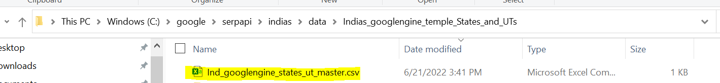

Step 2 :

cd c:\google\serpapi\indias

execute python

python serpapijsongetlocal.py

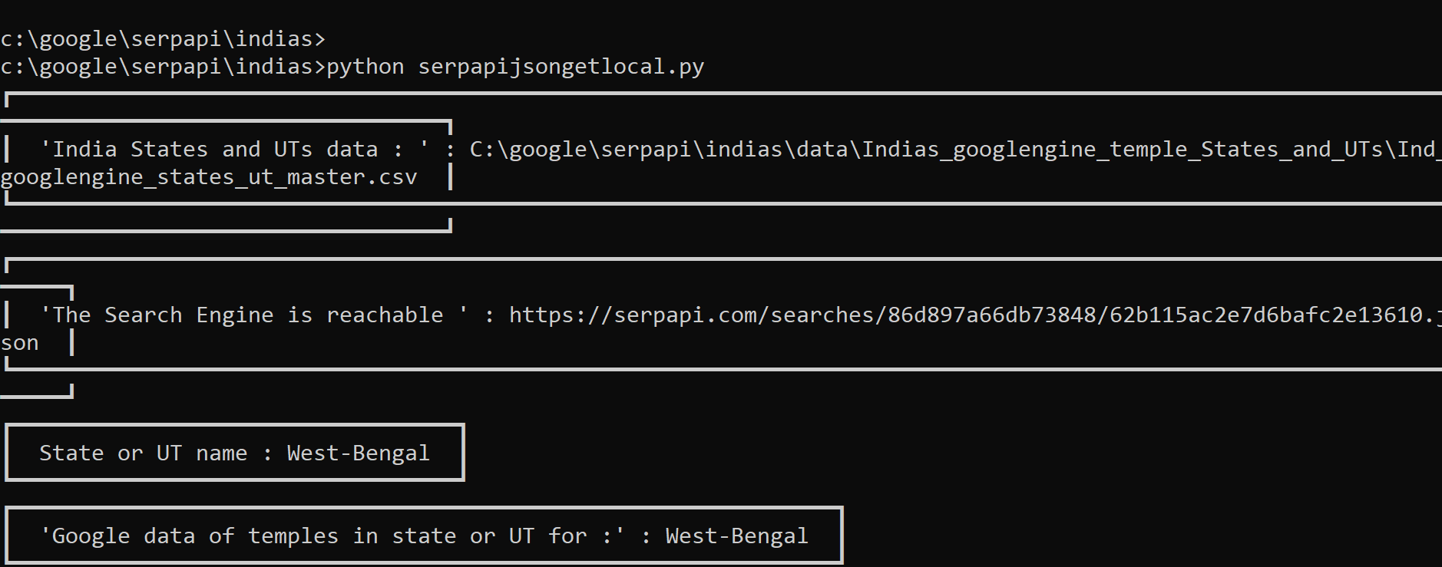

|  |  |  |
| --- | --- | --- |
| |  | | --- | | States and Union Territories in India | | West Bengal,Kolkotta | |
|  |

"api_key": os.getenv("API_KEY"), # your serpapi api key

Setting api_key in environment variable

Please write an email for request of SerpAPI - API Key

[Ramamurthy.valavandan@kyndryl.com](mailto:Ramamurthy.valavandan@kyndryl.com)

**Windows — API Key as Environmental Variable**

1. Click on Start and then type in **environment variable**

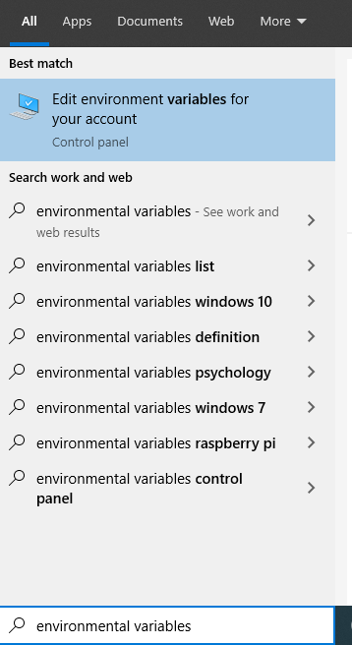

1. Click Edit environment **variables**for your account

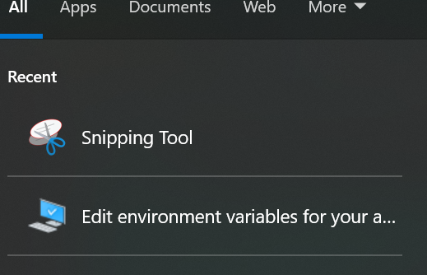

3. Click Environment Variables…

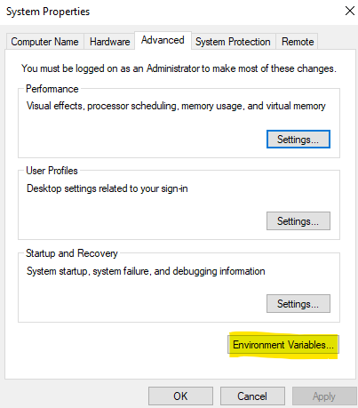

1. We are creating new user variable. Therefore, click on New… under user variable as highlighted in screenshot below
2. 